Project Design Phase
Solution Architecture

Date | 29 September 2026
Team ID | 6ab3da83a238dc999eb399a3
Project Name | AI-Augmented BlogNest API
Maximum Marks | 4 Marks

Solution Architecture:
Solution architecture for AI BlogNest API defines how the AI-powered backend system is designed, developed, integrated, and delivered. It connects the requirements of developers and blog applications with suitable backend and AI technologies.
Its goals are to:
● Provide an effective backend solution for blog applications by combining REST APIs with AI-powered services.
● Define the system structure, including the API layer, AI processing layer, database, authentication, and client applications.
● Describe the flow of data and requests between the user, backend API, AI services, and database.
● Define the major features and requirements, such as blog creation, content generation, summarization, categorization, keyword extraction, and content management.
● Reduce development effort by providing reusable API endpoints for common blog and AI-related operations.
● Ensure scalability and security so that the API can support increasing users, content, and application integrations.

Example - Solution Architecture Diagram:
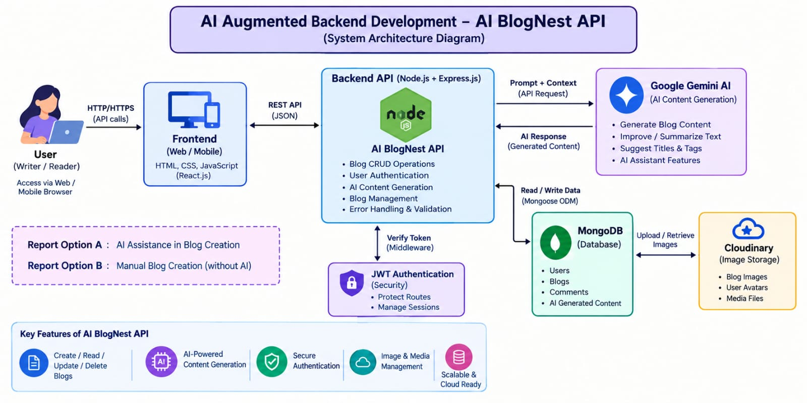
Figure 1: Architecture and data flow of the voice patient diary sample application

